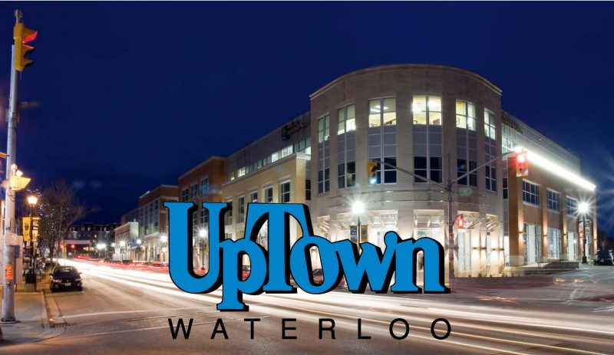
FIRE SAFETY
Ontario Fire Code Requirements Info. Session
For Business & Residential Building Owners
Date: Thursday November 20th
Time: 9:00-10:30am
Location: Waterloo Memorial Rec Centre
Lions Room #200
Free Refreshments & Snacks
Free Admission
RSVP: UpTown Waterloo BIA

