PHOTO RELEASE FORM
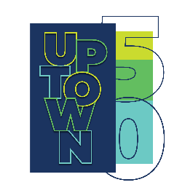

I, ___________________________________________________________________________________
Grant________________________________________ my permission to use the photographs taken of me for the Uptown Waterloo BIA photo contest and any legal use, including but not limited to: publicity, copyright purposes, illustration, advertising, and web content.

Furthermore, I understand that no royalty, fee or other compensation shall become payable to me by reason of such use.

Signature ________________________________________________
Date_____________________________________________________
Name (printed) ____________________________________________
Phone Number_____________________________________________

